
PREdictive Modelling
Project Assignment Question 1 (Cubic Zirconia)

March 10, 2021
Priyanka Pravinkumar Sukre
April’21 Batch

Contents
Linear Regression: 2
1.1 Read the data and do exploratory data analysis. Describe the data briefly. (Check the null values, Data types, shape, EDA, duplicate values). Perform Univariate and Bivariate Analysis. 3
1.2 Impute null values if present, also check for the values which are equal to zero. Do they have any meaning or do we need to change them or drop them? Check for the possibility of combining the sub levels of a ordinal variables and take actions accordingly. Explain why you are combining these sub levels with appropriate reasoning. 10
1.3 Encode the data (having string values) for Modelling. Split the data into train and test 11
(70:30). Apply Linear regression using scikit learn. Perform checks for significant variables using appropriate method from statsmodel. Create multiple models and check the performance of Predictions on Train and Test sets using Rsquare, RMSE & Adj Rsquare. Compare these models and select the best one with appropriate reasoning. 11
1.4 Inference: Basis on these predictions, what are the business insights and recommendations. Please explain and summaries the various steps performed in this project. There should be proper business interpretation and actionable insights present. 15

List of Tables:

S No | Table | Description
1 | Table 1.1 | Sample Dataset
2 | Table 1.2 | Null Values
3 | Table 1.3 | Datatypes
4 | Table 1.4 | Statistical Summary of Dataset
5 | Table 1.5 | Kurtosis and Skewness
6 | Table 1.6 | Categorical Variable Analysis
7 | Table 1.7 | Encoded Statistical Dataset
8 | Table 1.8 | Sample Encoded Dataset
9 | Table 1.9 | Train and Test Data dimensions
10 | Table 1.10 | Coefficients of Linear Regression
11 | Table 1.11 | Regression Results
12 | Table 1.12 | VIF

List of Figures:

S No | Figures | Description
1 | Fig 1.1 | Distribution and Box Plots on Continuous Variables
2 | Fig 1.2 | Correlation Matrix
3 | Fig 1.3 | Sample Pair plot
4 | Fig 1.4 | Price Predicted Vs Price Actuals

Linear Regression:

Problem 1:
You are hired by a company Gem Stones co ltd, which is a cubic zirconia manufacturer. You are provided with the dataset containing the prices and other attributes of almost 27,000 cubic zirconia (which is an inexpensive diamond alternative with many of the same qualities as a diamond). The company is earning different profits on different prize slots. You have to help the company in predicting the price for the stone on the bases of the details given in the dataset so it can distinguish between higher profitable stones and lower profitable stones so as to have better profit share. Also, provide them with the best 5 attributes that are most important.
Data Dictionary:
Variable Name | Description
Carat | Carat weight of the cubic zirconia.
Cut | Describe the cut quality of the cubic zirconia. Quality is increasing order Fair, Good, Very Good, Premium, Ideal.
Color | Colour of the cubic zirconia.With D being the worst and J the best.
Clarity | cubic zirconia Clarity refers to the absence of the Inclusions and Blemishes. (In order from Worst to Best) IF, VVS1, VVS2, VS1, VS2, Sl1, Sl2, l1
Depth | The Height of cubic zirconia, measured from the Culet to the table, divided by its average Girdle Diameter.
Table | The Width of the cubic zirconia's Table expressed as a Percentage of its Average Diameter.
Price | the Price of the cubic zirconia.
X | Length of the cubic zirconia in mm.
Y | Width of the cubic zirconia in mm.
Z | Height of the cubic zirconia in mm.

1.1 Read the data and do exploratory data analysis. Describe the data briefly. (Check the null values, Data types, shape, EDA, duplicate values). Perform Univariate and Bivariate Analysis.

To start with the analysis let us start understanding the data
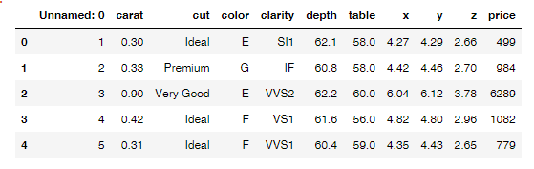
Table 1.1: Sample Data Set

- The dataset has a total of 11 variables with 7 continuous variables, three categorical type variables and one variables of Serial Number.
- Shape (Dimension of the dataset is 26967, 11)
- There were 697 null values present in the “Depth” variable alone and no null values present in other variables.
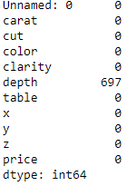
Table 1.2: Null Values

- Data Types: The dataset contains both Object, Int , Float data types.
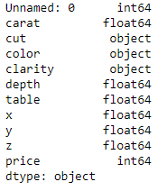
Table 1.3: Data Types
- Duplicate Values: There are no duplicate values present and in this particular Dataset duplicate values does not infer much because two or more diamonds may be having same parameters alike others.
- Univariate Analysis: To perform the Univariate analysis, let us start with looking at the summary of the dataset:
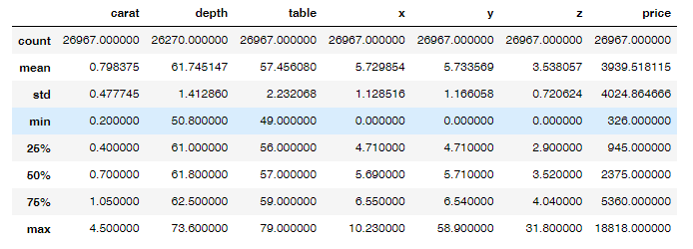
Table 1.4: Statistical Summary of the Dataset
- Inferences:
- The minimum carat is 0.2 and the maximum is at 4.5 and minimum price is 326 while the maximum price stands at 18818.
- Minimum values of Length, width and Height of the Gemstones is zero. Need to impute the values here as a tangible Gemstone should have a minimum of few parameters in Length, Width and Height.
- The carat values of the 75% data set is below 1.05 level.

Distribution and Box Plots:
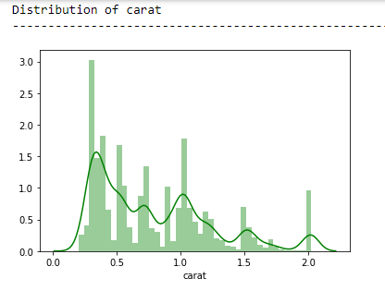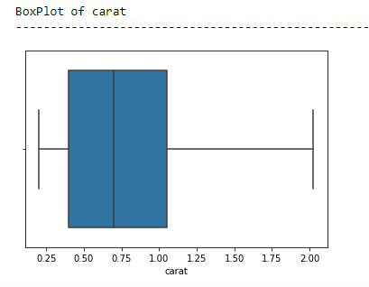
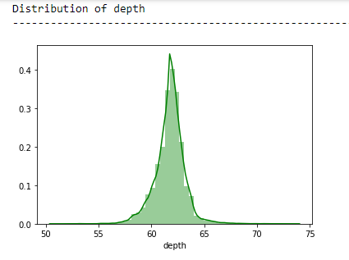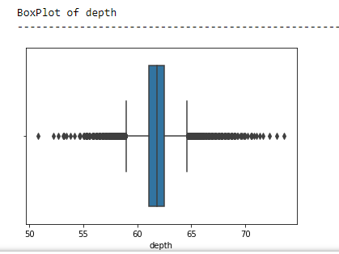
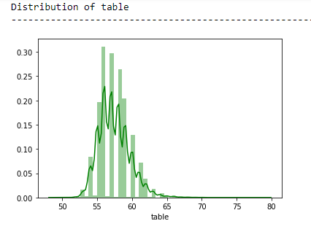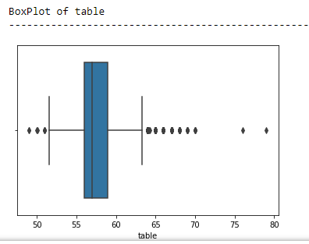
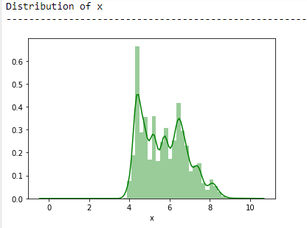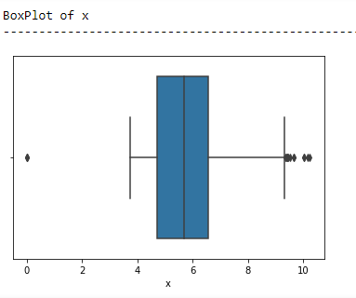

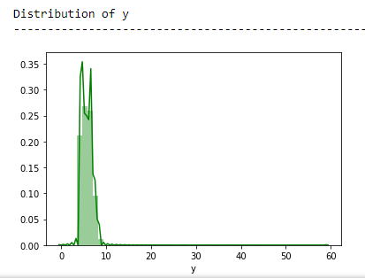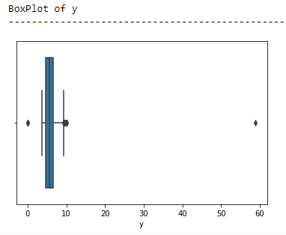
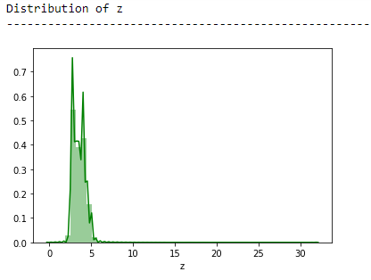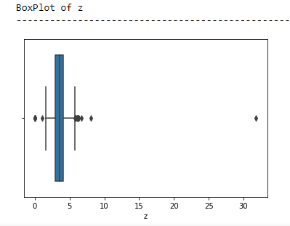
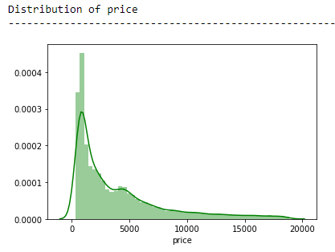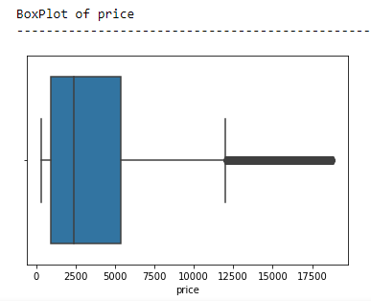
Fig 1.1 Distribution and Box Plots on Continuous Variables
Inferences from Univariate Analysis:
- From the box plots we can conclude that there are no outliers present in the carat variable
- Variable price having high proposition of the Outliers present.
- As 6 variables out of 7 variables have outliers we can treat the outliers equal to the whisker values i.e., Q1-1.5*IQR or Q3+1.5*IQR
- Variable carat having bimodal distribution
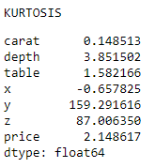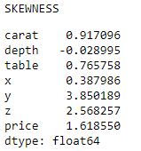
Table 1.5: Kurtosis and Skewness
- Other than depth all the variables have positive skewness i.e., to a longer on the left side of the distribution
- Variable x and carat are having low kurtosis having a near normal distribution
Categorical variable Analysis:
Inferences of Categorical Variables:
- Ideal cut with Green Color and SI1 Clarity Gems are counting high in the given dataset
- Ideal cut is out weighing the premium cut
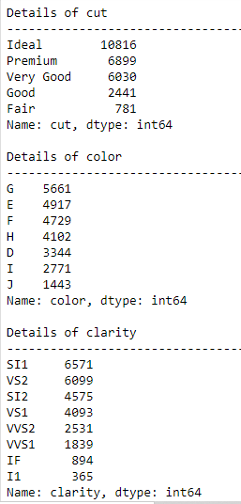
- I1 clarity Gems are very few compared to other clarities

Table 1.6: Categorical Variable Analysis

Multi-variate Analysis:
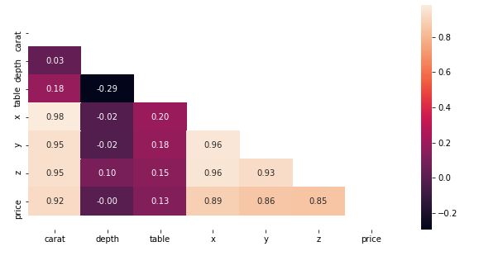
Fig 1.2 : Correlation Matrix
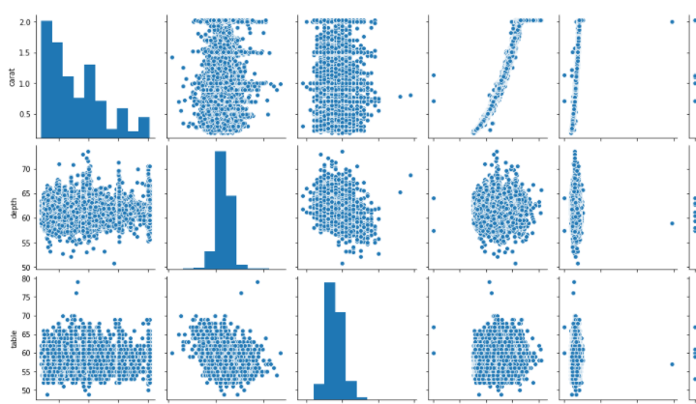
Fig 1.3: Sample Pair plot
Inferences from Multi-Variate Analysis:
- Top 3 correlation pairs are x, y and z with carat and price with carat
- Top three negative correlations or poor correlations are in the columns of depth and table
- There is clear possibility that the more carat attracts the high price.
- There is also clear possibility that more the diameters (length, width and height) of Gems greater the value of carat.

1.2 Impute null values if present, also check for the values which are equal to zero. Do they have any meaning or do we need to change them or drop them? Check for the possibility of combining the sub levels of a ordinal variables and take actions accordingly. Explain why you are combining these sub levels with appropriate reasoning.
Null Values from the dataset are as follows:
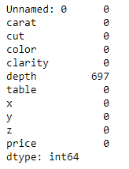
- From the above table it is evident that 100% null values are present in the variable depth. The null values have been imputed with the mean values as the depth variable is a continues variable with the mean 61.74 and with a low std of 1.41.
- Few values in the variables x,y,z are having the values as zero. Here these values will give as these values making the Gems dimensionless. So these values have considered as outliers and have treated with the nearest possible values. After imputing nearest value to the x,y,z which is equal to zero, the observed statistical data of the dataset is as below:
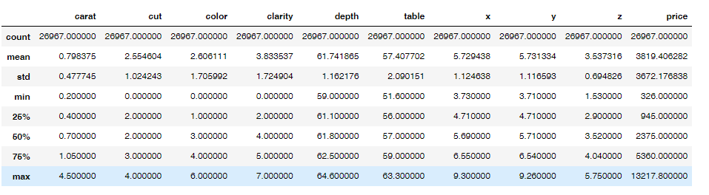
Table 1.7: Encoded Statistical Dataset
- Scaling: As this particular case is of multiple regression that is analyzing all the given variables as predicting one variable. As different variables have different parameters like width, price, length, depth, and few categorical variables are encoded here scaling in this case particularly not necessary as each variable have its variable importance. So in this multiple linear regression case scaling is not necessary.

1.3 Encode the data (having string values) for Modelling. Split the data into train and test


(70:30). Apply Linear regression using scikit learn. Perform checks for significant variables using appropriate method from statsmodel. Create multiple models and check the performance of Predictions on Train and Test sets using Rsquare, RMSE & Adj Rsquare. Compare these models and select the best one with appropriate reasoning.

From the dataset it is evident that, we have three categorical values CUT, COLOR and CLARITY. Ton preform the regression model we need to encode the categorical variables.
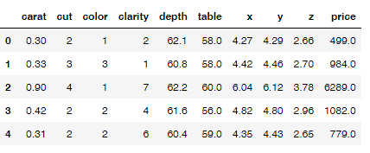
Table 1.8: Encoded sample Categorical Values
The sample dataset after encoding the categorical variables is above.
Train and Test Data:
From the dataset the train and test data is divided into two subsets with 70:30 ratio.
- Train Dataset: Used to fit machine learning model
- Test Dataset: Used to evaluate the fit machine learning model.
- The train test data is basically used when the dataset is large.
Below is the train test data from the dataset:
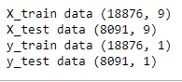
Table 1.9: Train and Test Data
- After fitting the Model into a linear regression the resultant co-efficients are as below:
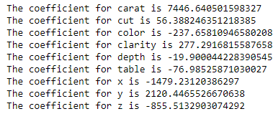
Table 1.10: Coefficients of Linear Regression
- The coefficient value signifies how much the mean of the dependent variable changes given a one-unit shift in the independent variable while holding other variables in the model constant.
- From the above coefficients for each of the independent attributes we can conclude
  - The one unit increase in carat increases price by 7446.640.
  - The one unit increase in cut increases price by 56.388.
  - The one unit increase in color decreases price by -237.65.
  - The one unit increase in clarity increases price by 277.291.
  - The one unit increase in depth decreases price by -19.90.
  - The one unit increase in table decreases price by-76.98.
  - The one unit increase in x decreases price by-1479.231.
  - The one unit increase in y increases price by 2120.446.
  - The one unit increase in z decreases price by-855.513.

- Regression Score Results:
  - Regression Score on Train Data is: 0.8928
  - Regression Score on Test Data is: 0.8937
From these two scores we can say that, the model is performing well have does not have over fir or under fit. The model has a good fit on train data.
  - RMSE Score on Train Data is: 1204.931
  - RMSE on Test Data is: 1189.625

From these two scores we can say that, the model is performing well have does not have over fir or under fit. The model has a good fit on train data.

Regression Results on Train Data:
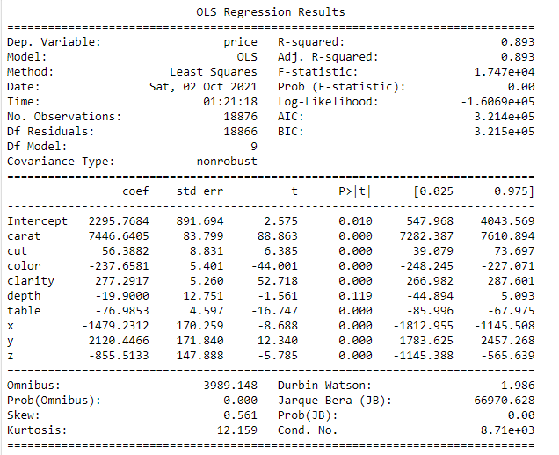
Table 1.11: Regression Results
- Adjusted R-Square will always be less than the R-Square.
- R-squared explains to what extent the variance of one variable explains the variance of the second variable. In this case the R2 of a model is 0.89, then approximately 89% of the observed variation can be explained by the model's inputs but it is important to use adjusted R-Square to determine any inconsistences in correlation. So we need to consider the adjusted R-Square here because of its ability to make a more accurate view.
- The p-values for the coefficients indicate whether these relationships are statistically significant. The p-value for each independent variable tests the null hypothesis that the variable has no correlation with the dependent variable. If there is no correlation, there is no association between the changes in the independent variable and the shifts in the dependent variable. In other words, there is insufficient evidence to conclude that there is an effect at the price level.
  - Depth variable is having the p-value > 0.05 and statistically their coefficients are not reliable.
  - All other variables other depth have p-values <0.05 so the statistically all these variables are significant and are good predictors.
  - Overall p-value is less than 0.05 so the model is reliable.

1.4 Inference: Basis on these predictions, what are the business insights and recommendations. Please explain and summaries the various steps performed in this project. There should be proper business interpretation and actionable insights present.
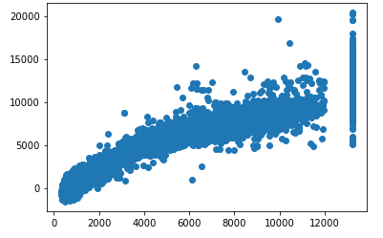
Fig 1.4:Price predicted Vs Price Actuals
It is evident that, from the linear plot, very strong corelation between the predicted y and actual y. But there are lots of spread. That indicates some kind noise present on the data set i.e Unexplained variances on the output as below:

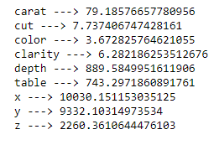
Table 1.12: VIF

The final Linear Regression equation is:

Price=
When one unit increase in carat increases price by 7446.640, keeping all other predictors constant.
There are also some negative co-efficient values, for instance, color has its corresponding co-efficient as -237.66. This implies, when the change in color, depth, Length of the Gem the price will decreases by corresponding units, keeping all other predictors constant.

On the given data set we can see the Length is in mm, having negative co-efficient. And the p value is less than 0.05, so can conclude that as higher the length of the stone is a lower profitable stones.
Similarly for the 'z' variable having negative co-efficient, and the p value is less than 0.05, so we can conclude that as higher the 'z' of the stone is a lower profitable stones.
The Five best attributes from the above equation is: CARAT, CUT, CLARITY, COLOR and WIDTH are the best attributes for price prediction.
  - CARAT is having high positive correlation
  - CUT,CLARITY, COLOR and WIDTH are having less standard deviation.
Overall, CARAT, CUT, COLOR, CLARITY,TABLE,X,Y,Z are the important features for model prediction.

The model has been performed after EDA, Univariate analysis, bi-variate analysis,, train and test, analyzing the regression scores and final regression results.
Recommendations:
The Gem Stones Company should consider the features 'Carat', 'Cut', 'color', 'clarity' and width (y) as most important for predicting the price.

